
CRM Project
SRS (SOFTWARE REQUIREMENTS SPECIFICATION)
Version 1.0
CRM System for ISEET Digital Transformation

Date: 5/4/2026
presented by: Hamzah Ghnimat

position: BA

Table of Contents

TITLE PAGE……………………………………………………..…1
INTRODUCTION…………………………………………………..3
DEFINITIONS………………………………………………………3
SCOPE……………………………………………………………….4
FUNCTIONAL REQUIREMENTS………………………………..4

NON-FUNCTIONAL REQUIREMENTS (NFRS)………………..8
1.WIREFRAME……………………………………………………..10
Homepage for iseet……………………………………………………..?
Crm system page……………………………………………………….?
Crm system page for manager ………………………………………..?
Crm system page for employees ………………………………………?
Client profile…………………………………………………………….?
Email, consulting time, all meeting…………………………………….?
2.MOCKUPS ………………………………………………………..15
Homepage ………………………………………………………………?
Log in……………………………………………………………………?
Manager page…………………………………………………………..?
Talk to us……………………………………………………..................?
Employee page………………………………………………………….?
client's page…………………………………………………..................?

INTRODUCTION

This document provides a detailed description of all the technical aspects that will be implemented in the Customer Relationship Management (CRM) system. It has 4 sections: Introduction, Functional Requirements, Non-Functional Requirements, and Wireframes.
This project will take all information from the client and put it in the CRM system, and that will improve the customer relationship.
A CRM system is essential for any organization that aims to manage its customer data in a structured and efficient way. By centralizing all client information in one place, the company will be able to improve communication, track customer needs, and deliver better service across all departments.

DEFINITIONS

- API (Application Programming Interface): used to connect the CRM with other systems.
- AI (Artificial Intelligence): showing the percentage of each client who benefit from our services.
- Notification: An automatic alert that tells users or employees about any important update or action needed.
- Dashboard: A main screen that shows a summary of data and key numbers at a glance.
- Authentication: Verifying who you are before entering the system using a username and password.

IN SCOPE AND OUT OF SCOPE

In Scope:
The system will use this information to know who uses our service and give the customer job opportunities, organize our company to be professional, and monitor the client. This includes tracking customer activity, managing their profiles, and ensuring that all internal processes are well-structured and easy to follow.
Out of Scope:
The system will NOT include:
- Salary management
- Resources management
- Third-party social media integration
- Mobile application
These features are excluded from the current phase as they fall outside the core CRM objectives and will be handled by separate systems.

Functional requirements

The system must create a button that takes you to a "Talk to us" page. This page will display the name of the person (text), the organization (text), the sector (text), the country (all countries and he will choice the country), and the email address must be a number, a text string, or a symbol, but it must contain the @ symbol, and the phone number must be a number.
Additionally, the system must create a "Submit" button. This button will collect all the information and enter it into the Customer Relationship Management (CRM) system and put it in database. The Submit button sends an HTTP POST request to the Laravel backend, which validates all fields server-side and stores the data in the MySQL database.

The system must create a CRM system that contains all customer profiles and create a large button that displays all their information when clicked. The button's title should be "Name and Company Name." Customer profile data is retrieved from the MySQL database via an HTTP GET request handled by the Laravel backend and rendered on the HTML/CSS/JS frontend.

When a customer profile is opened: it will display (Name (text), Company Name (text), Sector (text), Country (text), Email (button), Phone Number (integer), consulting time (button), Location (Google Maps), All Meetings (button). The Laravel backend retrieves all profile fields from the MySQL database upon profile selection and returns them as a JSON response to the frontend.

Clicking the "email" button will open a chat window with the client. The employee sends messages to the client, and these messages will appear in their email inbox. When the client replies, the message will appear in the chat window of the Customer Relationship Management (CRM) system. This is from the employee's perspective. Employee messages are sent via an HTTP POST request to the Laravel backend, which forwards them through SMTP to the client's email. Incoming client replies are received by the backend and stored in MySQL, then displayed in the CRM chat window through an HTTP GET request.

Clicking the "Consultation Time" button will open a page showing whether the client has requested a consultation by name and available time via the Consultation button on the ISEET homepage. An HTTP GET request is sent to the Laravel backend, which queries the MySQL database for the client's consultation records and returns them to the frontend.

Clicking the "All-Meetings" button will open a page displaying all meeting details, any reports, notes, communication history, and the client's interests, (after the consultation, and their activity) and any employee feedback about the client. An HTTP GET request retrieves all related records from the MySQL database via the Laravel backend. Any new notes or feedback added by the employee are saved through an HTTP POST request and automatically synced to the Manager's Reports section in the database.

Clicking the "Location" button will open a Google Map. The client's location coordinates are stored in the MySQL database. The Laravel backend retrieves them via an HTTP GET request and passes them to the frontend to render the map view.

The system must create a "Consultation" button for the client on the ISEET homepage. When clicked, a demonstration video will appear. To showcase our project and services, we will add a "Consultation" button. Below it. By clicking on it, the appropriate time for the meeting will appear. Before these steps, the employee will specify the time at which the manager can conduct the consultation, for example (every Monday: 5 pm). Available time slots are stored in the MySQL database by the employee via an HTTP POST request to the Laravel backend. When the client selects a time, the booking is saved through another HTTP POST request, and the backend triggers a notification to the relevant employee.

The system must receive a notification when the employee opens the client's profile if a consultation is available. When the employee opens a profile, an HTTP GET request is sent to the Laravel backend, which checks the MySQL database for pending consultations and returns a notification response if one exists.

The system must create a "Log In" button to appear when the manager or employee opens the CRM system. When clicked, we want to generate a username (text) and a password (number, text, or symbol). Login credentials are submitted via an HTTP POST request to the Laravel backend, which authenticates the user against the MySQL database and enforces role-based access control (RBAC): Managers see Reports, Schedule Meetings, Projects, and AI; Employees see the standard CRM view.

The system must create a "Reports" button for the manager when they open the CRM system. When this button is clicked, all reports or feedback from the client will appear on "Reports" based on the "All Meetings" button in the employee's user interface. An HTTP GET request is sent to the Laravel backend, which retrieves all synced employee notes and feedback from the MySQL database and returns them to the manager's dashboard.

The system must create a "Schedule Meetings" button for the manager when they open the CRM system. When this button is clicked, it will display whether the manager has a scheduled meeting with the client and send them a notification. Meeting records are retrieved from the MySQL database via an HTTP GET request to the Laravel backend. The backend also dispatches a notification to the client upon confirmation.

The system must create a "Projects" button for the manager when they open the CRM system. Clicking on this button will display a page from which the manager can enter all the projects we manage (Text). Project entries are submitted via HTTP POST to the Laravel backend and stored in the MySQL database. The projects list is retrieved via HTTP GET and rendered on the frontend.

The system must when employees open the CRM system and click "All Meetings" and add notes, reports, or concerns, all the information will be automatically sent to the Reports section of the manager's page. This sync is handled by the Laravel backend: when an employee submits new data via HTTP POST, the backend automatically updates the manager's Reports table in MySQL with no manual action required.
The system must include a "Job Opportunities" button on the ISEET homepage for clients to view available opportunities. Additionally, the system must provide employees with a dedicated button or interface that allows them to add job opportunities. Once a job is added by an employee, it should automatically appear in the "Job Opportunities" section on the homepage. An HTTP POST request is sent by the employee to the Laravel backend to add new job opportunities, which are stored in the MySQL database, and then automatically retrieved via an HTTP GET request and returned to the frontend for display in the Job Opportunities section on the homepage.

The system must create an "AI" button for managers when they open the CRM system. Clicking this button will display a page showing the following information: Name (text), Company (text), and Percentage (integer). This percentage will be retrieved from the "All Meetings" section of the employee's homepage and will be used to determine whether the client will use our services now or in the future. An HTTP GET request triggers the Laravel backend to query the MySQL database for All Meetings data. The backend applies the prediction logic and returns the calculated percentage for each client to the frontend.

Non-Functional Requirements (NFRs)

1. Security & Data Privacy
- Authentication: Access to the CRM must be secured via encrypted credentials and multi-factor authentication (MFA).
- Authorization (RBAC): Implementation of Role-Based Access Control to ensure restricted features (e.g., Reports, AI metrics) are only visible to Managers.
- Data Encryption: End-to-end encryption for all communications between the CRM chat system and client emails.

2. Performance & Efficiency
- Response Time: Customer profiles and map locations must load within a maximum threshold of 2 seconds.
- Concurrency: The system must handle multiple simultaneous chat sessions and data entries without degradation in performance.
- Real-Time Notifications: Alerts regarding consultation availability or profile access must be delivered within 5 seconds.

3. Usability & Validation
- Data Integrity Validation: Strict front-end and back-end validation for email formats (presence of @), phone numbers (integers), and mandatory fields.

4. Availability & Reliability
- System Uptime: A guaranteed availability of 99.9% for the ISEET homepage and the internal CRM.
- Data Consistency: Automated, loss-less synchronization between employee notes in "All Meetings" and the Manager's "Reports" dashboard.

5. Integration & Interoperability
- External API Stability: Seamless and stable integration with Google Maps API for real-time location tracking.
- Email-to-Chat Gateway: A robust communication bridge to ensure seamless message conversion between CRM chat and SMTP (Email) protocols.

6. Scalability & Future-Proofing
- Resource Scalability: The "Projects" module must support an unlimited number of entries without impacting database search speed.
- Algorithm Flexibility: The AI logic for calculating "Future Service Usage Percentage" must be modular to allow for easy updates to the predictive model.
7. Hosting Requirements
- The system will be hosted on the Cloud using a provider such as AWS or Azure to ensure scalability, accessibility, and low maintenance overhead.
8. Language Support
- English as the default language.
- Arabic will be supported as a secondary language, including RTL text direction and localized formatting.

WIREFRAME

Homepage for ISEET

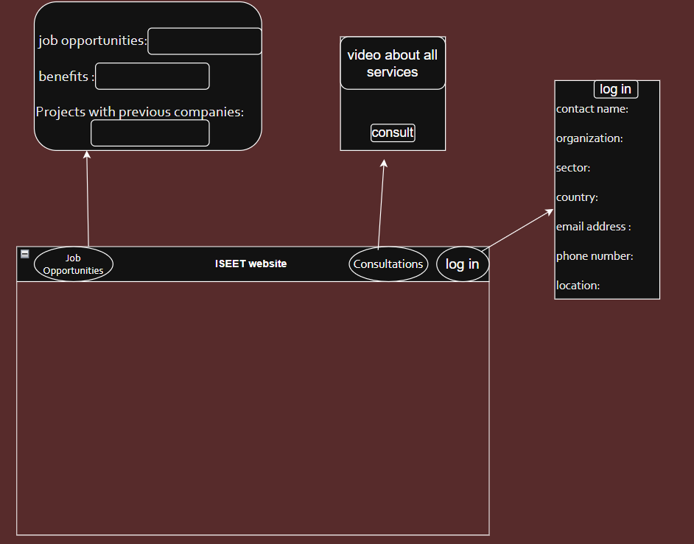

CRM System Page

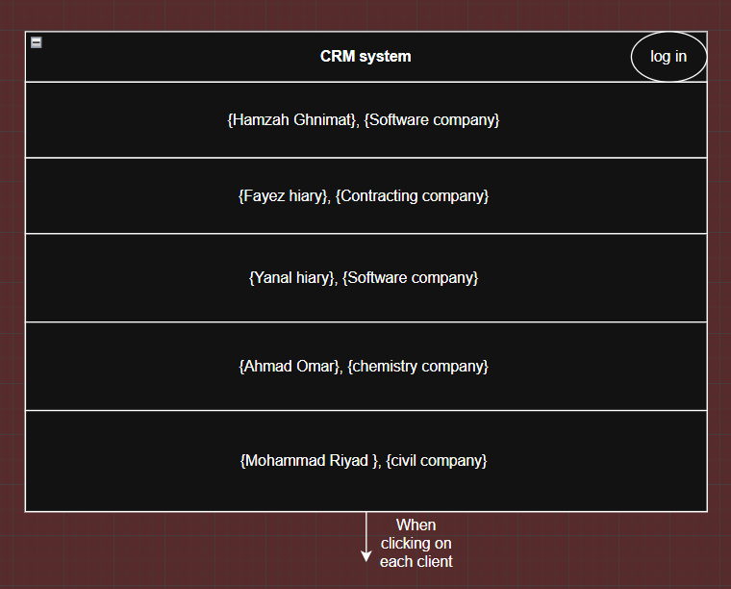

CRM System Page for manager

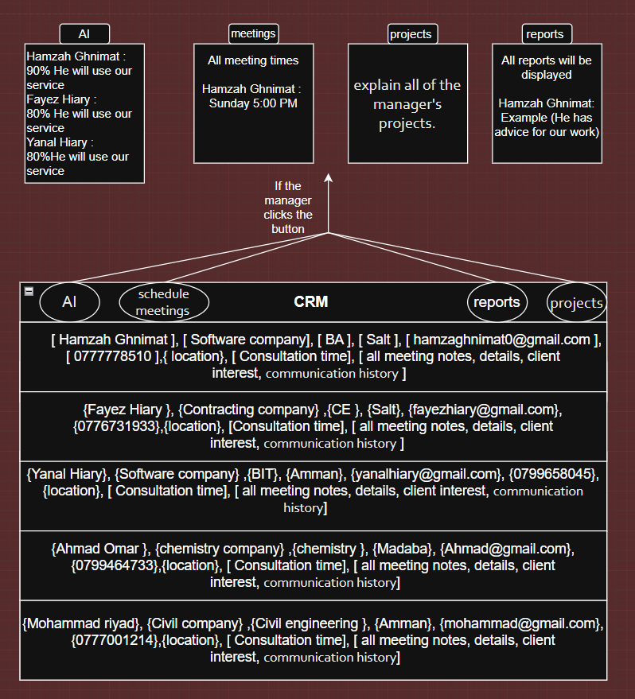

CRM System Page for employee

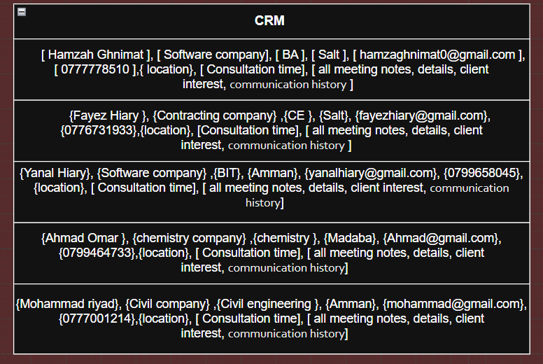

Client profile when click on (Email, Consulting time, All meeting)

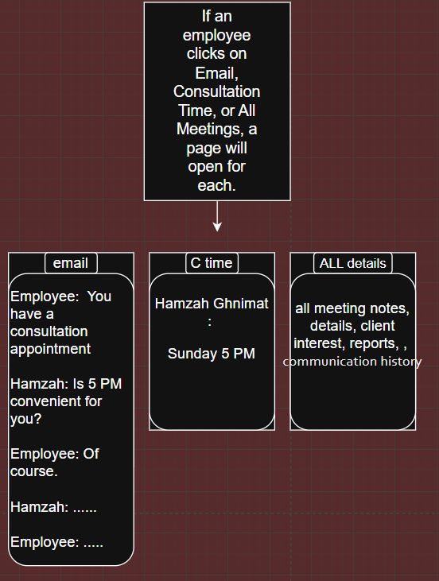

MOCKUPS

Homepage

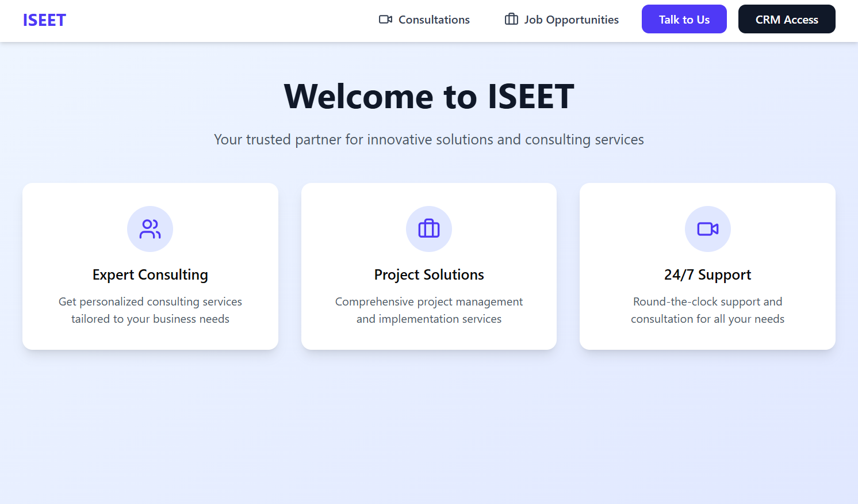

Log in
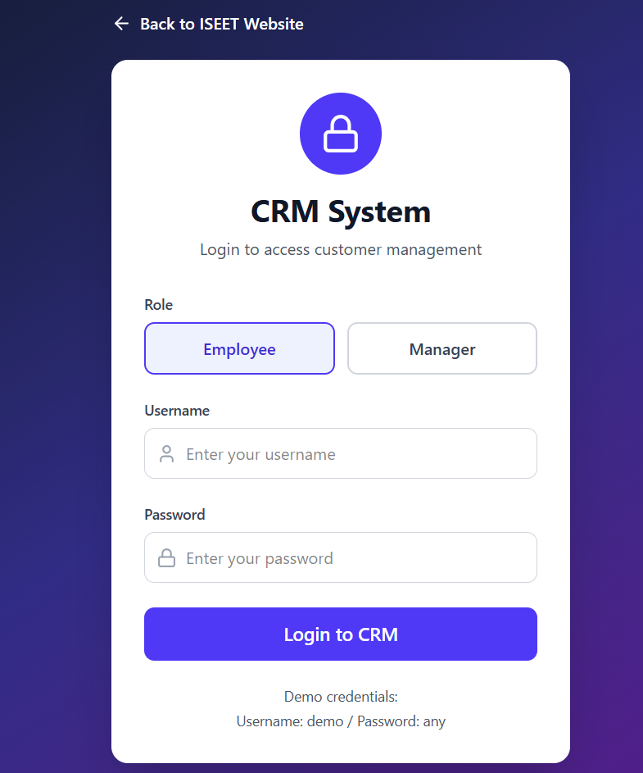

Manager page
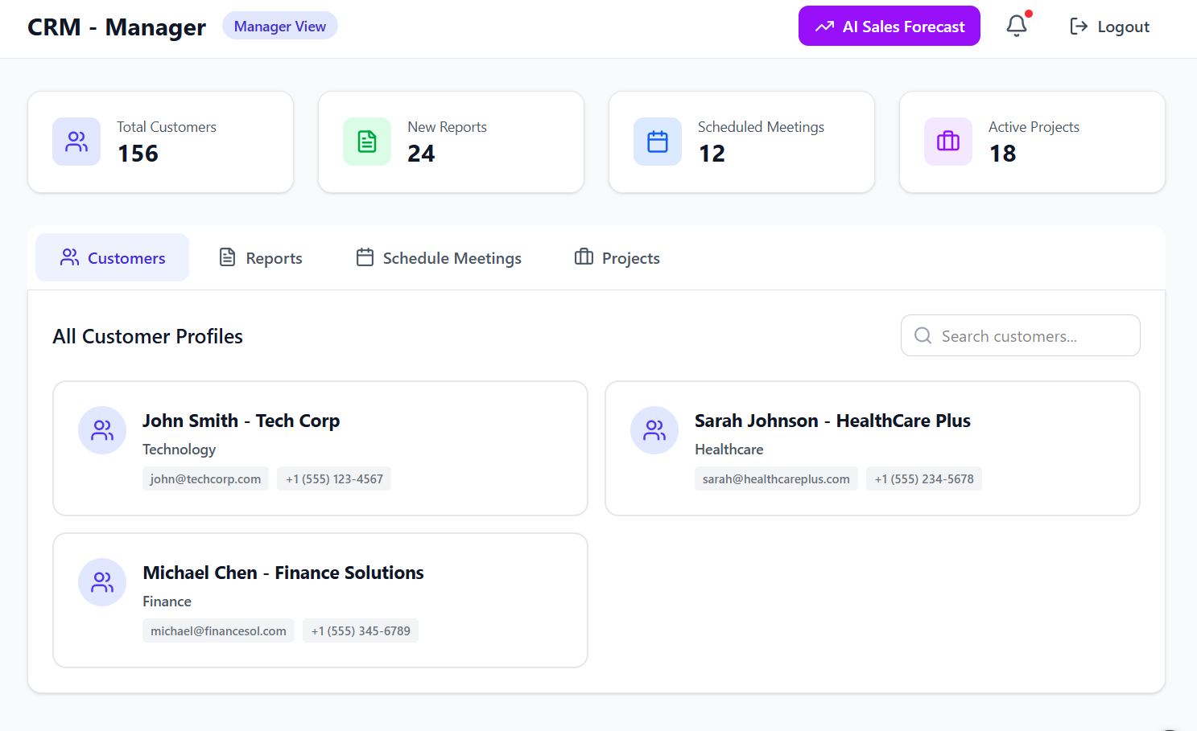
Talk to us
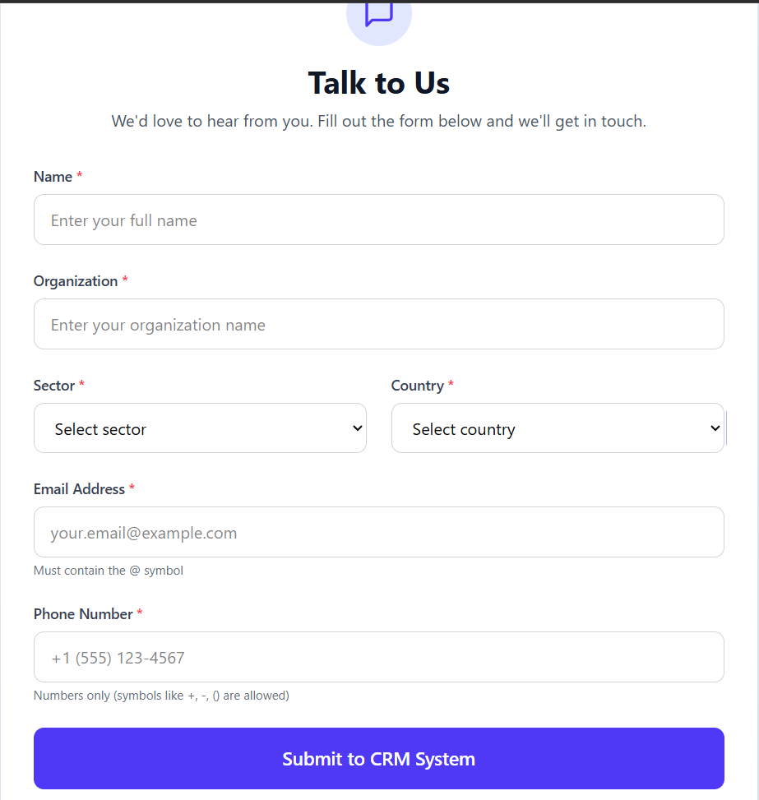

Employee page 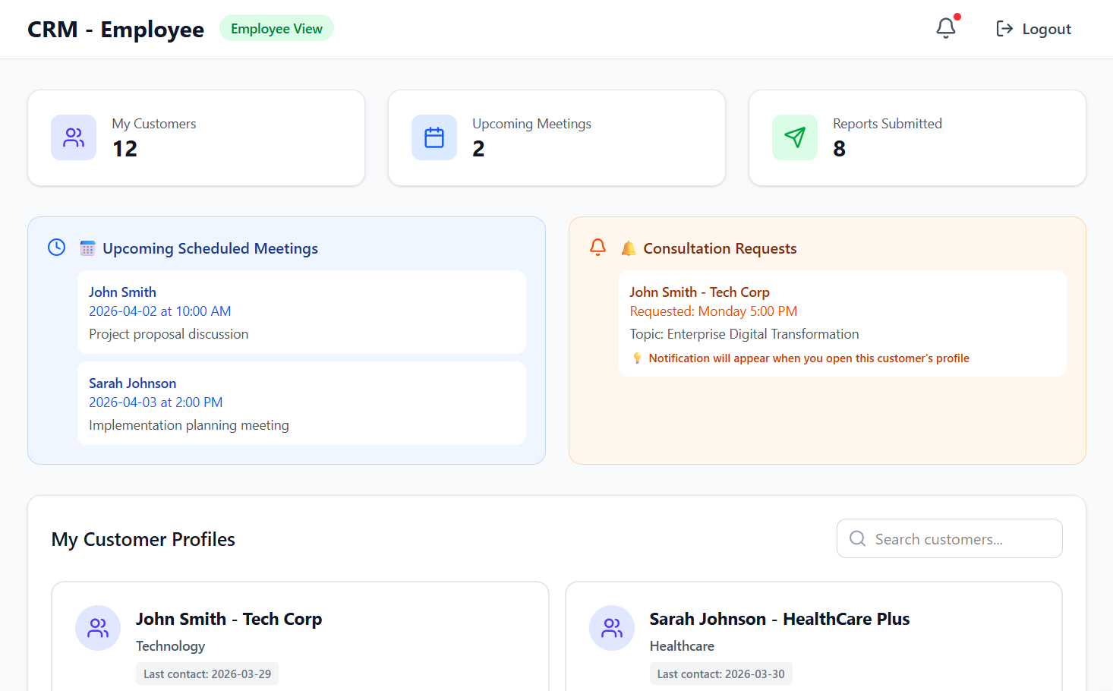

This is a client's page
